**Chapter One**

**Introduction**

# **Overview**

SOU (Skyline Online University) website is a modern approach to enlist as many students worldwide in an academia gathering to help them with their education regardless of their financial status, background, or their location. SOU offers degrees in many programs for students who are willing to put in the effort to expand their horizon and learn more and become more productive to their society. SOU uses modern technologies to enable features that are deemed necessary at the current day and provides a secure platform for students and tutors.

SOU consists of three main sub-systems, one for executives, the other for tutors, and the last for students, each separated and independent from each other. The students sub-system SIS (Student Information System) offers many features for students, but most importantly, it offers an integrated learning system that allows students to watch educational videos and read course materials within the website, in a fashioned way, which helps keeping the students activities all in one place and reduce any distractions during studying sessions. It also enables students to add and drop courses during a semester, check assignments and upload solutions, check their grades, and use other features.

Apart from students, tutors at SOU have their own sub-system TIS (Tutor Information System) that enables them to view important aspects of their job, perform CRUD (Create/Read/Update/Delete) operations on course materials, perform CRUD operations on exam questions, and prepare assignments and upload them to the course assignments for students to solve and return via the website.

The EIS (Executive Information System) allows executives to perform CRUD operations on almost all database tables, granting them full access and control over it.

The executives are responsible for managing and organizing the university, and make sure everything works as expected.

* 1. **Project Motivation**

Online universities have been rising since the mid 90’s, and more people are beginning to realize that the future of education is online, however, most online universities don’t take into consideration many features that are critical for students when using the online platform. Accumulated experience in web development and experience as a student in the new generation provides an opportunity to develop a platform that meets such requirements.

There are two reasons for picking such a huge project, the first reason, is helping people with bad circumstances to complete their education and earn a degree. The second reason is the hope to make this platform known worldwide and accepted on a national level, and hopefully make a big change in the way the current education system is managed.

* 1. **Aim and Objectives**

The aim for this project is to launch SOU on the world wide web, to become accredited and accepted worldwide and to be a beacon for students seeking a high-level education experience.

The objectives are as follows:

1. To allow students worldwide to register at the university and enroll in courses through the semesters.
2. To provide a modern, comfortable platform for the students to use while studying, course materials such as PDF’s and support videos are to be provided in the website, all which can be used directly within the platform.
3. Allow tutors to upload assignments and grade students submissions.
4. Provide a platform for executives that allows them to perform CRUD operations on the database which includes tables such as colleges, programs, courses, etc.
   1. **Scope**

SOU consists of 2 major parts, the frontend website, and the backend system, which is built upon three sub systems, the SIS (Student Information System), the TIS (Tutor Information System), and the EIS (Executive Information System).

The front-end website allows website visitors to learn about the university, check available colleges, programs, and courses, and read about other related information.

The backend system as denoted earlier in the overview section consists of three sub-systems, all of which are independent and secure, and have their own unique dashboard that suits the needs for their intended users. The first sub-system the SIS, denies access to users other than students, however, registered students have full access to the SIS panel, which includes multiple features such as:

1. Check student enrollment information.
2. Add and drop courses related to his program.
3. Check grades and financial status.
4. Check the program plan and costs.
5. Use the integrated E-Learning system, that allows students to watch enrolled course videos, read course materials , all within the E-Learning system.
6. View or download uploaded assignments, and upload solutions for them.

The second sub-system is the EIS, which allows access only to executives, offering them a wide range of control and flexibility over the database. The EIS allows executives to perform CRUD operations against the database on the following tables:

1. Colleges.
2. Programs.
3. Courses.
4. Executives.
5. Tutors.
6. Students.
7. Positions.
8. Sections.

The third and final sub-system is the TIS. TIS grants access to SOU tutors only, and provides them with tools that enables them to do the following:

1. Check sections they are currently responsible of.
2. Perform CRUD operations on current sections courses materials, such as course videos and course documents.
3. Perform CRUD operations on current sections course assignments.
4. Read submitted assignments and grade them.
5. Perform CRUD operations on current sections course exam questions bank, and their related answers.

People can visit the website and navigate through different pages that includes dynamic information about SOU different colleges, programs, courses, and requirements, they can also communicate with SOU support team, and can fill an online application form if interested in joining the university. Users other than registered students are restricted from logging into the SIS unless registered and provided with login credentials. Furthermore, students are restricted from accessing the other systems such as the online staff platform and vice versa.

Upon registration, personal details such as name, age, email and password are stored as records in a relative table within the SOU database.

Depending on the program the student has enrolled in, and courses completed, relative courses will show on his platform if the prerequisites are complete should there be any prerequisite.

SOU website is browser compatible, meaning it can run on any modern browser on any operating system with similar results, it is also built with the mobile first approach concept, meaning it is fully functional on different screen sizes with clear and understandable design.

* 1. **General Constraints**

The major constraint faced while working on this project is the inability to access multiple online university student platforms, this has limited the ability to gather more information on what students are missing and to join the dots together. Limited time is another constraint that prevented the inclusion of all the planned features on the first release and must be postponed to future releases.

* 1. **Document Organization**

The way this document will be organized is through following steps in an ascending order, from most basic to more complicated material and based on the work schedule.

This section is in progress and will be finalized once the document is complete.

**Chapter Two**

**Background and Related Work**

# **2.1 Theoretical Background**

University as a definition is an “[institution](https://www.britannica.com/topic/institution) of [higher education](https://www.britannica.com/topic/higher-education), usually [comprising](https://www.merriam-webster.com/dictionary/comprising) a [college](https://www.britannica.com/topic/college-education) of [liberal arts](https://www.britannica.com/topic/liberal-arts) and sciences and graduate and professional schools and having the [authority](https://www.britannica.com/topic/authority) to confer degrees in various fields of study. A university differs from a college in that it is usually larger, has a broader curriculum, and offers graduate and professional degrees in addition to undergraduate degrees” (Britannica, 2019).

Universities in our time are considered the corner stone for any country to develop economically and technologically and be able to progress through time. Countries today are rated by their scientific achievements and their capacity to produce well educated citizens who are seen as the fuel for innovation and progression. However, universities and education in general weren’t as important in the past as they are today.

## The first existing university ever was the University of Al-Karaouine, founded in 859 in the city of fez, morocco. Since then, many universities arose in western Europe such as University of Bologna, 1088 and University of Oxford, 1096.

Universities didn’t change much since then, and until 1989, things began to change with the dawn of the internet where the first online university was established, however, the first fully online university was the university of Catalonia founded in 1994 *(theculturetrip, 2016).*

1. **Old Universities – A Brief History**

Early organizations of higher learning existed well before colleges were built up. These early establishments directed research and showed understudies, like our thoughts of colleges today. Early accounts from Egypt and Mesopotamia propose there were researchers who directed research as well as these researchers likely instructed and were partnered with establishments of learning. The Ashurbanipal Library at Nineveh and Library at Sippar were accumulations of information that imaginable likewise had understudies and educators related with them that showed a select gathering of people who not just took in the complex composed dialects of their day yet in addition started to examine and apply their insight *(theculturetrip, 2016).*



Figure 1: Tablets from the Ashurbanipal era, believed to be used in his great library (Source: <https://www.twipu.com/MosulEye/tweet/1164119638122401792>)

The primary establishment that was all the more completely recorded was the Dispassionate Foundation, established in 387 BCE, with Aristotle's Peripatetic school established in 335 BCE having gotten from Plato's Institute. These schools commonly had a chosen few understudies and were not organizations for mass instruction *(theculturetrip, 2016)*.

Maybe one of the principals really global foundations of advanced education was the Museum, an establishment that carried learning to it from around the known world. The Library of Alexandria was a piece of this establishment and it filled in as an archive for learning from the Greek world as well as collected information from Babylonia and Persia that had gone before Greek grant. The Museum generally worked like a worldwide college, where understudies would come to be taught by the best instructors. The Ptolemaic state was tolerant to grant and enabled people from numerous areas to come to Alexandria to be associated with this organization *(theculturetrip, 2016)*.

Figure 2: Depiction of Plato's Academy (Source: <https://towardsdatascience.com/plato-aristotle-and-machine-learning-521c3252cbd1>)

In the antiquated world, a few areas created customs of grant. In the Indian subcontinent, Pushpagiri and Nalanda were two surely understood focuses of advanced education. These foundations were given to Buddhist instructing yet in addition prepared people in expressions, medication, science, and space science. Indeed, even legislative issues, or something practically identical to political theory, or political hypothesis, was instructed at these institutes. Prior Hindu higher learning cetnres, for example, Taxilia, additionally drafted understudies. This spot progressed toward becoming related with one of the most punctual monetary treatises known to us, a book called the Arthashastra, which talked about different subjects too, for example, political statecraft *(dailyhistory, 2019)*.

China had built up a magnificent foundation to prepare officials during the Han line in Taixue by the first century CE. While prior foundations were progressively likened to private establishments, the supreme preparing framework the Chinese created turned out to be increasingly like state funded instruction. The school appeared to enroll understudies across the nation and affirmation depended on aptitudes and honors, showing that by then advanced education had turned into a type of social portability and mass training. Up to 30,000 understudies may have gone to the foundation at a given time. Later in the first thousand years CE, the school started to build up an assessment framework that assessed its enlisted classes *(dailyhistory, 2019)*.

In antiquated Persia, during the Sasanid line at around third century CE, Gundishapur worked as a therapeutic preparing and advanced education institute. This institute kept on working for quite a while after the appearance of Islam and ended up one of the key impacts and establishments for Islamic advanced education that succeed it *(dailyhistory, 2019)*.

In Europe, during the Roman and later Artifact period, grant kept on following the Dispassionate convention built up by the Greeks. Be that as it may, these establishments were shut by the sixth century CE, because of their relationship with agnostic practices and ways of thinking. With the fall of the Roman Realm, grant wound up kept to secluded religious communities. These religious communities prepared people in adapting, for the most part the individuals who progressed toward becoming ministers or priests and started to archive a portion of the Greek and other information from an earlier time *(dailyhistory, 2019)*.

1. **Islamic Universities – A Brief History**

Islam has set a high priority on instruction from the very beginning and has enjoyed a long and rich scholarly tradition. Knowledge (' ilm) has an enormous situation within Islam, as evidenced by more than 800 references to it in the most venerated book of Islam, the Koran. The significance of training is over and again underlined in the Koran with visit directives, for example, "God will exalt those of you who believe and those who have knowledge to high degrees" (58:11), "O my Lord! Increase me in knowledge" (20:114), and "As God has taught him, so let him write" (2:282). Such stanzas give a mighty improvement to the Islamic people group to make progress toward instruction and learning *(stateuniversity, 2019)*.

Thanks to the highly inclusive influence of the Koran, Islamic teaching is unusually not quite the same as different types of instructive theory and practice in large measure. As a detailed blueprint for both the individual and society, the Koran stands in as the central source of information. For the largely uneducated Middle Eastern culture, the introduction of the Koran in the seventh century was very radical. A rich oral tradition had been valued by the Middle Eastern culture, yet the Koran was seen as the voice of God and should obviously have been co-operatedwith methods of reading and recounting his expressions. So, perusing and writing to meet the Koran's full favors was a practice for Muslims in general. Training in Islam so acquired its birthplaces undeniably from a beneficial relationship with strict guidance *(stateuniversity, 2019)*.

Along these lines, thusly, Islamic training started. Devout and learned Muslims (mu' allim or mudarris), committed to making the lessons of the Koran progressively available to the Islamic people group, trained the dedicated in what came to be known as the kuttāb (plural, katātīb). The kuttāb could be situated in an assortment of scenes: mosques, private homes, shops, tents, or even out in the open. History specialists are questionable about when the katātīb were first settled, yet with the across the board want of the dedicated to ponder the Koran, katātīb could be found in for all intents and purposes all aspects of the Islamic realm by the center of the eighth century. The kuttāb served an imperative social capacity as the main vehicle for formal open guidance for essential age kids and proceeded so until Western models of training were presented in the cutting-edge time frame. Indeed, even at present, it has displayed astounding strength and keeps on being a significant method for strict guidance in numerous Islamic nations *(stateuniversity, 2019)*.

The educational program of the kuttāb was essentially coordinated to youthful male youngsters, starting as ahead of schedule as age four, and was fixated on Koranic examinations and on strict commitments, for example, ceremonial ablutions, fasting, and petition. The concentration during the early history of Islam on the instruction of youth mirrored the conviction that bringing up kids with right standards was a heavenly commitment for guardians and society. As Abdul Tibawi wrote in 1972, the psyche of the youngster was accepted to be "like a white clean paper, when anything is composed on it, right or wrong, it will be hard to eradicate it or superimpose new composition upon it" (p. 38). The way to deal with instructing youngsters was severe, and the conditions wherein youthful understudies educated could be very brutal *(stateuniversity, 2019)*.

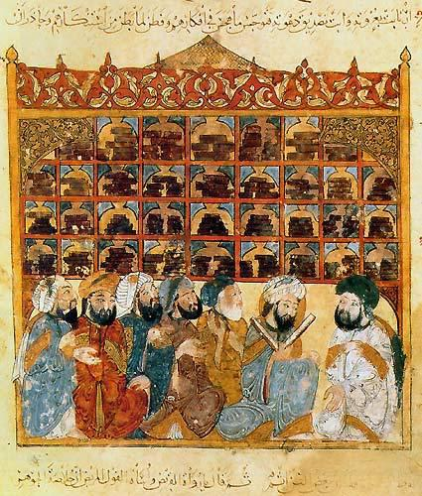

Figure 4: Islam Golden Age University (Source: <http://bukharimailru.blogspot.com/2014/07/blog-post_26.html>)

Flogging was frequently used to address lethargy or imprecision. Remembrance of the Koran was fundamental to the educational program of the kuttāb, yet practically no endeavor was made to investigate and talk about the significance of the content. When understudies had remembered most of the Koran, they could progress to higher phases of training, with expanded multifaceted nature of guidance. Western experts of the kuttāb framework generally condemn two territories of its teaching method: the restricted scope of subjects instructed and the select dependence on remembrance. The contemporary kuttāb framework still underlines remembrance and recitation as significant methods for learning. The worth put on remembrance during understudies' initial strict preparing legitimately impacts their ways to deal with realizing when they enter formal instruction offered by the cutting-edge state. A typical dissatisfaction of current teachers in the Islamic world is that while their understudies can remember bounteous volumes of notes and reading material pages, they frequently need fitness in basic examination and autonomous reasoning *(stateuniversity, 2019)*.

During the brilliant age of the Islamic domain (normally characterized as a period between the tenth and thirteenth hundreds of years), when western Europe was mentally in reverse and stale, Islamic grant thrived with a noteworthy receptiveness to the reasonable sciences, workmanship, and even writing. It was during this period that the Islamic world made the majority of its commitments to the logical and creative world. Incidentally, Islamic researchers safeguarded a significant part of the learning of the Greeks that had been precluded by the Christian world. Other exceptional commitments were made in zones of science, herbal science, material science, mineralogy, arithmetic, and stargazing, the same number of Muslim scholars viewed logical facts as instruments for getting to strict truth *(stateuniversity, 2019)*.

Bit by bit the open and fiery soul of enquiry and individual judgment (ijtihād) that described the brilliant age offered route to a progressively separate, unquestioning acknowledgment (taqlīd) of the customary corpus of definitive information. By the thirteenth century, as indicated by Aziz Talbani, the 'ulama' (strict researchers) had progressed toward becoming "self-delegated translators and gatekeepers of strict information.… learning was kept to the transmission of conventions and creed, and [was] antagonistic to explore and logical request" (p. 70). The mindset of taqlīd ruled in all issues, and strict researchers censured every single other type of request and research. Epitomizing the taqlīd attitude, Burhän al-Clamor al-Zarnüji composed during the thirteenth century, "Stick to antiquated things while maintaining a strategic distance from new things" and "Be careful with getting to be immersed in those questions which occur after one has cut free from the old specialists" (pp. 28, 58). A lot of what was composed after the thirteenth century needed inventiveness, and it comprised generally of critiques on existing standard works without including any substantive new thoughts. The deadly mix of taqlīd and outside attack starting in the thirteenth century served to diminish Islam's superiority in both the imaginative and logical universes *(stateuniversity, 2019)*.

In spite of its brilliant heritage of prior periods, the Islamic world appeared to be not able react either socially or instructively to the invasion of Western progression by the eighteenth century. One of the most harming parts of European imperialism was the weakening of indigenous social standards through secularism. With its reverence of human explanation over awesome disclosure and its emphasis on division of religion and state, secularism is utter horror to Islam, in which all parts of life, otherworldly or transient, are interrelated as an amicable entirety. Simultaneously, Western establishments of instruction, with their articulated common/strict division, were mixed into Islamic nations so as to create functionaries to sustain the bureaucratic and managerial needs of the state *(stateuniversity, 2019)*.

The early modernizers didn't completely understand the degree to which secularized training on a very basic level clashed with Islamic idea and customary way of life. Strict training was to stay a different and moral obligation, having no spot in state funded instruction. In the event that Muslim understudies wanted strict preparing, they could enhance their current training with moral guidance in customary strict schools–the kuttāb. As an outcome, the two varying training frameworks advanced freely with next to zero authority interface *(stateuniversity, 2019)*.

1. **Modern Universities – A Brief History**

The quantity of colleges began to develop rapidly in Europe by the late medieval and early present-day time frame, whereby about 143 colleges were most likely to be found in the eighteenth century. It includes various types of specialized educational establishments that, for example, did not call themselves universities. The Paris College began building up the possibility of resources separating study areas. Center topics that began to be developed in colleges were theory, where the standard title for PhDs is still specialized in logic, diagnosis, reasoning, religious philosophy, law, arithmetic, stargazing, and sentence structure. Such sections of the study were allegedly viewed from a humanistic point of view, the same number of interpretations expected of antiquated works given the focus on control *(dailyhistory, 2019)*.

Early colleges were inflexible and heavily influenced by Aristotle's ideas regarding academic disciplines and learning. Nonetheless, researchers began to try different things with better learning and experimentation methods. Orders started to split away from a substantial impact of humanistic impacts. This prompted the disparate improvement of the sciences from the humanities inside an instruction framework. By the eighteenth century, colleges additionally started creating research diaries, urging researchers to distribute and course their discoveries with different researchers. In Germany, Wilhelm von Humboldt created thoughts of scholastic opportunity, workshops, and research centers as a route for colleges to encourage discussion, learning, and new logical request *(dailyhistory, 2019)*.

Figure 3: Depiction of Medieval University Gathering (Source: <https://www.scoop.it/topic/history-and-historians/?&tag=universities>

State-funded universities open to the majority over the nineteenth century have turned out to be largely far-reaching. Religion began to turn out to be less of a major concentration in the educational program noticeably in the nineteenth century. This bit by bit made colleges common advanced education establishments and, with the improvement of the Modern Insurgency, numerous colleges started to all the more enormously center around the sciences as industrialization created as a type of rivalry between the Western world. In England, the idea of the municipal college was viewed as a motor for building up a mainstream, financial potential that utilized the majority by giving them access to training *(dailyhistory, 2019)*.

The English Domain and later other European realms started to transplant the European model of training the world over. While the US started to embrace a portion of the German model for an exploration college, a great part of the remainder of the world likewise was ingrained with European ideas. These then wound up unavoidable and dug in inside nations to such an extent that when provincial forces lessened in the twentieth century, the college frameworks they either established or had encouraged as instructive models were to a great extent kept in spots, for example, India, Kenya, and in the Center East *(dailyhistory, 2019)*.

1. **Online Universities – A Brief History**

While distance education has been a long history, online education was developed just over a decade and a half ago— a relatively short time in academic terms. The early delivery of courses via the web began in 1994, followed soon by a more structured approach using the new class management systems category *(Phil Hill, 2017)*.

In the 1800s, the first correspondence courses started using parcel post to meet students who were unable to be on campus. Communication systems were advanced by the early 1900s, and distance education was brought to the radio waves. The amateur radio service opened in 1919 at the University of Wisconsin, becoming the first licensed radio station dedicated to educational broadcasting. Shortly afterwards, by the advent of television, access to higher education was again expanded; giving birth to what was known as telecourse *(Phil Hill, 2017)*.

Iowa University started experimenting with television in the 1930s for educational purposes. It was not until the FCC started reserving broadcasting frequencies for educational purposes in the 1950s that telecourses caught the public's attention. Through creating the Corporation for Public Broadcasting (CPB) in 1967, the importance of television for education was furthered. The mission of the CPB was to promote the growth and advancement of public broadcasting, including the use of these media for economic, educational and cultural purposes *(Phil Hill, 2017)*.

In 1982, when the Western Behavioral Sciences Institute opened its School of Management and Strategic Studies in La Jolla, California, online learning began. The University of Phoenix started offering educational programs via the internet in 1989. Online learning started to grow in 1993 with the release of the first web browser developed by the University of Illinois. The first fully online programs were established in 1998: New York University Online, the University of Western Governor, the Virtual University of California, and Trident University International *(Phil Hill, 2017)*.

In 2000, only 8% of students were enrolled in an online course, but up to 20% by 2008. The growth of online education has not slowed either; nearly 30% of all post-secondary students were enrolled in some form of distance education by the fall of 2013. While online course and program completion statistics are complex, researchers noted high attrition levels (ranging from 20% to 50%) among online students relative to those taking traditional face-to-face courses *(Phil Hill, 2012)*.

Online education has since grown in popularity slowly but steadily, to the extent where almost one-third of U.S. post-secondary students took at least one online course in the fall of 2010. Fast forward to 2012: Massive Open Online Courses (MOOCs) is a new concept that creates broad interest in higher education circles. Perhaps notably, it has opened strategic conversations about online education in higher education cabinets and boardrooms. Stanford, MIT, Harvard, California-Berkeley University, and others have thrown their support— in terms of investment, money, and presidential support— behind MOOCs ' transformative power and online education *(Phil Hill, 2012)*.

While educators continue to discuss important issues such as accessibility, affordability, and higher education personalized learning, they would be supported by a better understanding of the improvements that are already taking place. Most online learning takes place through the learning management system (LMS) of a college or university. An LMS is an educational resource management, distribution and monitoring software application. According to the Educause Center for Analysis and Research (ECAR), the use of an LMS is almost omnipresent as 99 percent of universities and colleges report having one in place *(Phil Hill, 2012)*.

87% of teachers report using an LMS and find it useful to "improve teaching (74%) and student learning (71%)." Likewise, in their classes, 83% of students use an LMS, with the majority (56%) using it in most or all of the courses *(Phil Hill, 2012)*.

Many companies use LMSs from external suppliers (77%), while Blackboard currently dominates the LMS world with an adoption rate of 31.9%, followed by Moodle at 19.1%, and Canvas at 15.3%.[17 ] Nevertheless, Canvas, by Instructure, has gained a growing market share in the past year. Reflecting these changes, the ECAR announced that 15% of institutions are in the process of updating and/or replacing their LMS; the main reasons given were the need for "upgrading functions (71%), replacing legacy systems (44%) and reducing costs (18%)" *(Phil Hill, 2012)*.

1. Figure 4: LMS market share for US and Canadian Higher Ed institutions (Source: <http://eliterate.us/state-higher-ed-lms-market-spring-2016/>)

ECAR's institutional survey found that both faculty and students are generally satisfied with the LMS; three-quarters are satisfied with the LMS for content posting (faculty) and information access (students). By comparison, the lowest levels of satisfaction recorded by faculty with the LMS were with features that allow "meaningful" interaction between students and their teacher, students and other students, as well as study groups or project collaboration. Likewise, less than half of the students surveyed registered LMS satisfaction with "engaging in positive student experiences." Although LMSs are used to a large extent as a repository for course materials (e.g. syllabus, learning content, etc.) and learning assessment platforms, recent developments make them more flexible by LTI standards *(Phil Hill, 2012)*.

The Next Generation Digital Learning Environment will be more responsive to the needs of students, providing a more personalized environment, according to a study from the Educause Learning Initiative. The practical characteristics of the next generation of digital learning environments include: "interoperability and integration; personalization; assessments of data, education and learning; collaboration; and usability and uniform design" *(Phil Hill, 2012)*.

Most existing systems used in online universities are built using either the Moodle system or using WordPress, those systems rely heavily on complicated security measures which leads to slower loading times and a bad experience for the students.

SOU (Skyline Online University) system does not ignore the security measures required to ensure the safety of all students personal information and the integrity of the university data, however, since SOU is built from scratch up for certain known operations using different modern technologies, it's easier to bypass certain security measures that are used in commercial platforms such as WordPress and the Moodle, due to it being used by many different universities and institutions, they have the obligation to insert security measures for most if not all known security breaches methods, whether that method that leads to such breach exists in the university system or not.

**2.2 Analysis and limitation of existing systems**

SOU system intends to build an enhanced version of the existing systems used in online universities by allowing students to benefit from online courses and support materials within the system without the need to search for them or spread the focus on multiple websites. Most students spend a hefty amount of time searching for supporting materials which can enhance their understanding of the subjects they enroll in. along with the time spent searching for such materials, the students quite often feel confused and exhausted from the search process.

SOU system also includes multiple modern and aesthetic charts to help students understand different aspects of their situation right from the dashboard of their admin panel, they will always be in touch of their progress and have a better understanding of their situations.

Thus, to conclude, the most factor that hardens the studying process for online students is the chaos they find themselves in, not knowing what to do, and where to search for information. This will not be a problem with SOU as everything will be provided to them, focusing more on educating the student rather than teach him how to search for education and knowledge.

**2.3 Need for new system**

During meetings with well-educated personal and professors in academia, the conclusion was made that many students as well as professors feel that the current existing systems are quite dull and outdated, they feel that a need for further development and more modern approach is needed, and thus SOU system intends to further upgrade its system in the near future to integrate modern tools and technologies and implement modern design that fit the needs of the new generations that will be more appealing to them and easier to use.

The backbone frame for such upgrades are in place and will be implemented once at a time for testing reasons.

**Chapter Three**

**Project Methodology**

**3.1 Project Planning**

3.1.1 Feasibility Study

The feasibility study is an estimate of whether, using existing software and hardware technologies, etc., the specified can be achieved under the current budget. The feasibility study should be cheap and quick; the decision to continue the project should be told or not.

* + 1. Executive Summary

The SOU is a virtual university that tends to gather students from all around the world in one platform to help them achieve their undergraduate studies regardless of their location, their income, or their age. It provides high standard education through a team of enthusiastic individuals that includes high status professors and well-known successful individuals.

Several technologies and tools were used to achieve a modern and aesthetic platform with great performance such as PHP, JavaScript and Morris.Js.

This project is aimed to be on an international level, although, the intuitions are low, the income will be generated by numbers of students rather than high course costs, this helps both the university and the student alike.

Online universities have been multiplying since the dawn of the world wide web, and research shows that it is making huge success. The future of academia and learning is moving toward the internet more than ever.

* 1. Description of product/ service

Online universities have been spreading since the dawn of the internet, the first appearance was in 1989, however the first online university to launch only on the world wide web was in 1996, since then, many universities followed track after seeing the success.

Many students worldwide can’t afford university costs or are too far away to attend classes on a daily basis, therefore, the online universities were the best solution for them, which make a good percentage of the population, especially in third world countries.

Most online universities per researches conducted haven’t evolved much and lacks in the design and modern aesthetics, it also lacks ease of use and good plans that help students during their studies, this is where SOU tends to make a difference.

* + 1. - Technology Considerations

To achieve a modern website, it must be built from scratch up with custom code using modern technologies and tools rather than premade and ready platforms such as the Moodle which lacks design approaches and WordPress which lacks good performance.

* + 1. SOU marketplace

SOU is a worldwide university that welcomes students from all over the world. It is not concerned about their situations, their intelligence, their location, or any other matter, the only important factor is their will to make a change and educate themselves to be more efficient and helpful to their societies.

* 1. Marketing strategy

The marketing is the most important factor to make this project a success, and to achieve that, there are several approaches to follow, such as using social media advertisement campaigns heavily, using google AdWords and other web-based advertisement solutions.

Since SOU focuses on the world wide web exclusively, it only makes sense to focus on the marketing resources and focus on the www too.

* + 1. Schedule

The project has been initiated since the first of June, and has been in development ever since, with the end of December as the launch date. It has already gone through multiple phases and achieved almost 75% of all tasks till date. However, there is much more work to do and the following Gantt chart clearly states the schedule in detail.

* + 1. Financial Projection

The revenue expected from this project is to be in millions of dollars after its launch in a couple of years. the low tuition cost will attract millions of students under the poverty line, and these low costs when multiplied by millions of students makes a decent revenue. But the most attracting factor relied on is making the university degree accredited in most countries, and the plans for that have already been drawn, and high academic and social individuals and organizations have already been put in the picture and acknowledged.

* + 1. Findings and recommendations

Due to the intensive research, it has been found that online universities is on the rise and spreading faster than traditional universities, and it is expected to be the standard way of teaching in the future due to its low costs, and its wide reach.

It is recommended that this project is to be continued further into the future and more technologies to be integrated into the platform with further research to be made to better understand the needs of current and future student generations.

3.1.2 Gantt Chart

The Gantt chart shows the project process, the project started at June 1st, 2019 with the aim to launch at 26th Dec 2019.

**3.2 Software Development Methodology**

3.2.1 User requirements

Functional Requirements

The user's functional requirements have been narrowed down to the most important activities a student needs in order to interact with SOU.

Many activities were removed from the website to keep it simple and clear for the student to know what tasks need to be done on regular visits. Limiting the number of activities, the student can perform helps him retain focus on the more important activities rather that shattering his focus on less useful ones.

Non-Functional Requirements

Limiting these requirements were also the main concern as it helps with the website performance and its ease of use as well.

Limiting the nom functional requirements to several important ones has made it easier in the development process as well for the user, who can understand the process of the platform in less time, and thus, feeling the platform is more familiar to him within a couple of visits only.

3.2.2 System Requirements

The system requirements put little pressure on users, allowing the platform to accept users from different regions and with different capabilities. Since the website supports all modern browsers, users won't face issues running through the website. Also, more poor users who have low end computers can run the website just fine, the website is light and performs fast enough to ensure a great experience for all users.

3.2.3 Domain Requirements

The domain requirements were conducted through few meetings with different professors and online students, and it appears, that they all agree that the domain requirements are rather simple and few. The main object is to provide a modern and easy to use website with few functions to keep the focus of students on the important aspects of studying, such as providing a pdf viewer and video player within the website, with all the necessary materials to select from.

**3.3 Analysis of the new system**

3.2.1 User requirements

- Functional Requirements

1. Users should be able to use the website from any modern browser.
2. Users Should be able to navigate the website with ease using the megamenu, pages side-menu and footer menu.
3. Users should be able to fill an application in order to apply to the university.
4. Users should be able to login to their admin panel within the SIS should they have been accepted into the university and provided with login credentials.
5. Users should be able to send messages to the university support team directly from the website.
6. Users should be able to add and drop classes once they are accepted as students.
7. Users should be able to check their schedule and enlisted courses.
8. Users should be able to check their program plan.
9. Users should be able to logout from their admin panel.
10. Users should be able to request a brochure directly from the website.

- Non-Functional Requirements

1. The sub-systems should deny access to the system should the login credentials be false.
2. The website should show different program requirements when users navigate different programs.
3. The website should show dynamic menus that change based on users' selected college, program, and courses.
4. The website should send a brochure to the user’s email upon request.
5. The website should deny access to users trying to directly access nested forms and the system using a URL path.
6. The system should display the users name and photo when logged into the system.
7. The system should display online users to logged in users when logged into the system.
8. The system should navigate the user back to the login page when the user logs out from the admin panel.

3.2.2 System Requirements

1- The website requires an internet connection for users to use the platform.

2- The website requires users to have a personal email in order to apply to the university.

3- The website requires users to have a modern browser or modern version that is at most 7 years old.

3.2.3 Domain Requirements

1- provide a platform to students that allows them to study from and find video and document learning materials.

2- Update learning materials to the latest versions.

3- Provide students with tutors contact details for further help in their studies.

**Chapter Four**

**Software Design**

Any successful and modern software system must abide to the rules of software requirements engineering, that is, the way toward comprehension and characterizing what services are required and distinguishing the limitations on these services.

Engineering specifications processes ensure that your code meets the user's needs and ends up with a highquality software. It is a critical stage of the software process as errors at this stage will later reflect on the next stages, which will result in higher costs

for you.

A specifications report will be produced and validated with the stockholders at the end of this point, describing the requirements. There are four main requirements engineering activities (or sub-activities):

Figure 4.1 Requirements engineering activities

Unified Modelling Language (UML) is one of many standard languages used in software engineering to specify, visualize, construct, and document different parts of a software system. UML has evolved since it was found; to better versions that made it easier to use and understand.

Figure 4.2 UML Diagram Hierarchy

* 1. **Use Case Diagram**

A UML use case diagram is the primary form of system / process requirement for a new underdeveloped software program. Use cases define the intended activity (what) and not the exact procedure (how) to do it. Using cases as defined, it is possible to denote both textual and graphic representation (i.e. using case diagram). A key concept for use case modeling is that it allows a program to be constructed from the end user's point of view. It is a customer-specific effective communication mechanism for system activities by identifying all externally visible system activity.

A case diagram is usually easy to use. It does not display the specifics of the use case, it only outlines some of the relationships that occur between use cases, actors and systems. It does not define the order in which steps are taken to achieve the goals of each situation.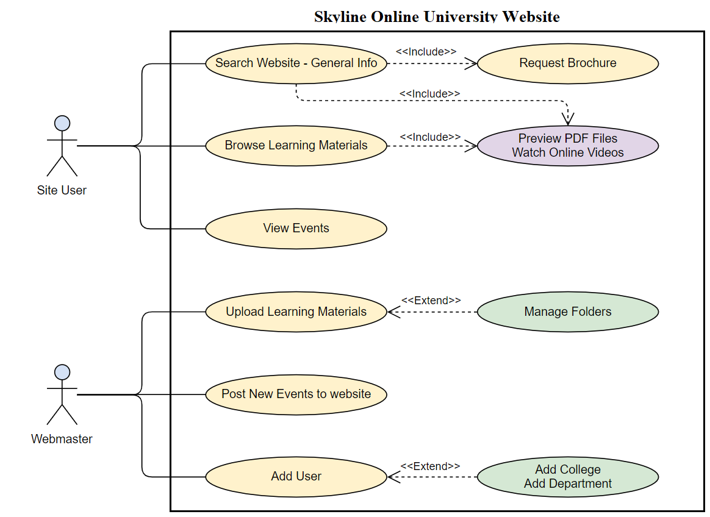

Figure 4.3 Use Case Diagram

* 1. **Design of Database**

Database creation is the process of creating a structured model for the database. This data model includes all the conceptual and physical design choices and physical storage parameters required to produce a specification in a data description language that can then be used to create a database.

A database model shows the logical structure of a database, including the relationships and constraints that dictate how data is stored and accessed. The database model used in this project was developed using the usual types of database design rules and concepts.

Figure 4.4 Database Design

The following Entity Relation Diagram (ERD) shows all the details of the relations between the tables used.

Figure 4.5 Entity Relation Diagram (ERD)

* 1. **Class Diagram**

A Unified Modeling Language (UML) model diagram in software engineering is a type of static structure diagram that describes the structure of a system by showing the system classes, their attributes, operations (or methods) and object relationships.

Class Diagrams Purposes:

1. Shows a system's static classifier structure.
2. The chart provides a basic notation for other UML-prescribed structure diagrams.
3. Good developers as well as other members of the team.
4. From a business perspective, business analysts can use class diagrams to model systems

As much as the importance of classes in modern time when developing software, the best suited approach was structural programming rather than heavily relying on classes. That is not be understood that classes weren’t used, however, its use was minimized and only several minor classes were used.

* 1. **Sequence Diagram**

UML Sequence Diagrams are diagrams of interaction describing how operations are done. In the sense of cooperation, we capture the communication between objects. Sequence diagrams are time based and visually show the order of the communication by using the diagram's vertical axis to represent time what and when messages are sent.

Captures of sequence diagrams:

1- An interaction occurring in a collaboration that either performs a use case or an operation (instance diagrams or generic diagrams).

2- High-level interactions between system administrators, system managers, other systems or subsystems (sometimes referred to as system sequence diagrams).

Sequence Diagram Purposes:

1- Model high-level communication in a process between active objects.

2- Design the communication of object instances in a partnership that performs a use case.

3- Model the interaction of objects in a collaboration that performs an operation.

4- Either model generic interactions (showing all possible paths through interaction) or particular interaction instances (showing only one path through interaction).

Figure 4.6 Sequence Diagram

* 1. **Activity Diagram**

Another important behavioural diagram in the UML diagram is the activity diagram to describe system dynamic aspects. In essence, the activity diagram is an advanced version of the flow chart modelling the flow from one activity to another.

Task Diagrams explain how tasks are organized in order to provide a product that can be abstracted at different levels. Usually, certain operations need to accomplish an action, particularly where the operation is intended to accomplish a number of different things requiring coordination, or how events relate to each other in a single use case, in particular use cases where activities overlap and need coordination.

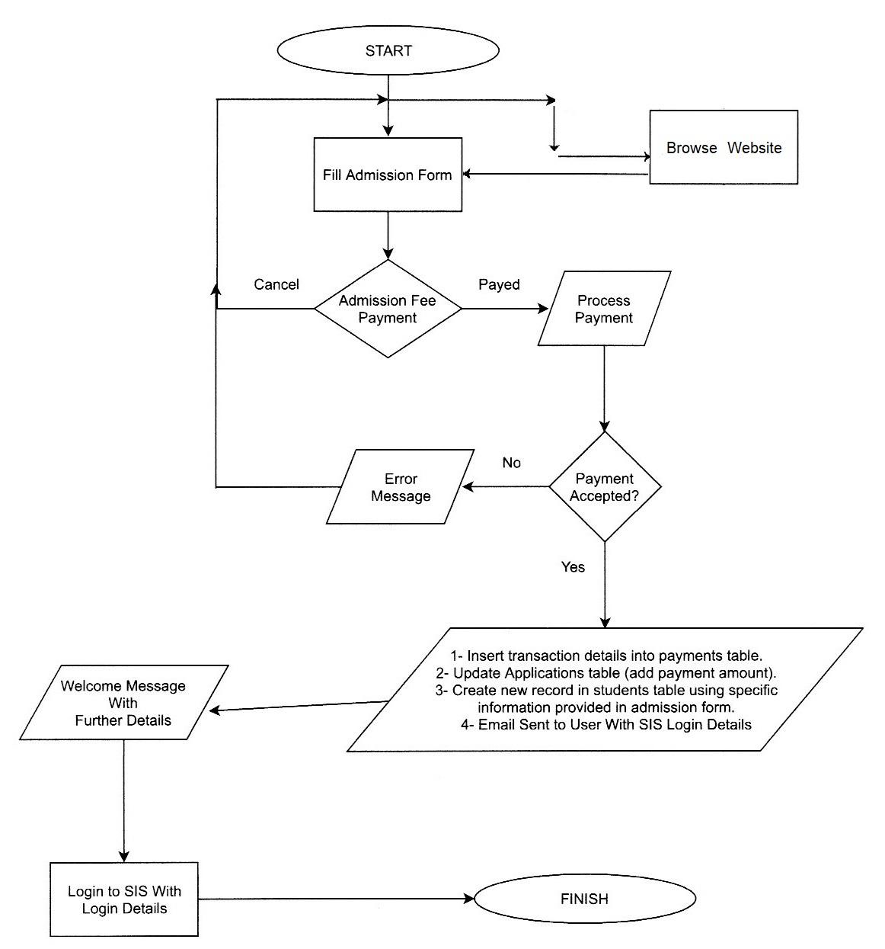

Figure 4.7 Activity Diagram